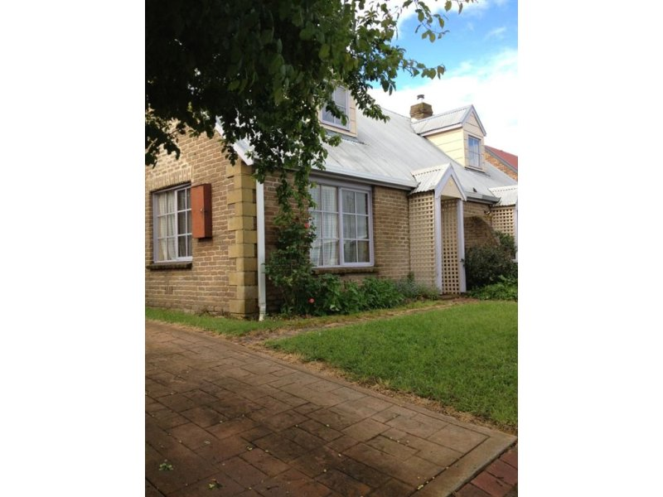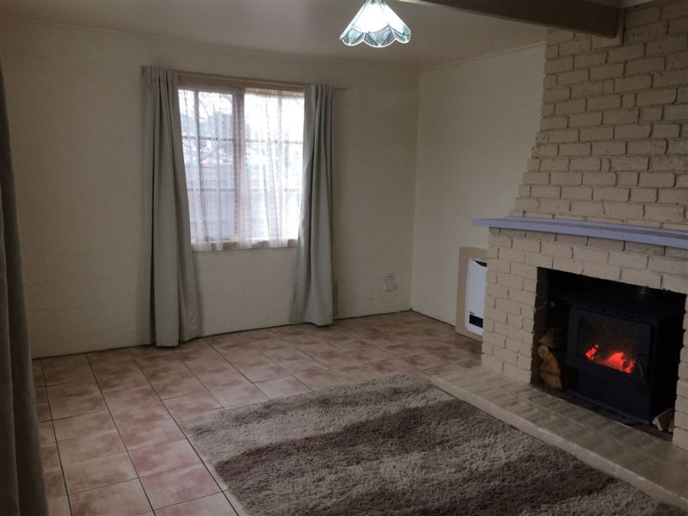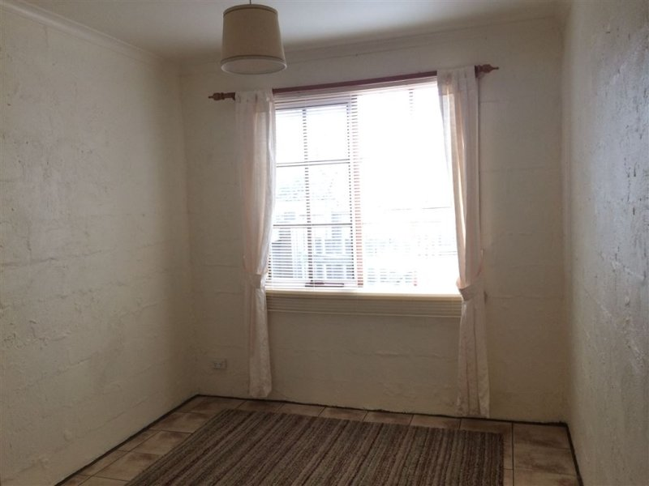 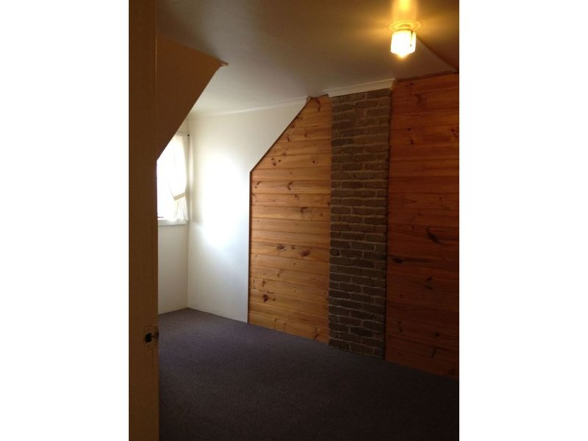

- Open plan living area  
- Enclosed rear yard  
- Rear verandah   
- Within walking distance to local amenities  
Property Layout & Yard Features;  
- 2 bedrooms upstairs, 1 bedroom downstairs   
- Well appointed bathroom  
- Spacious kitchen with electric cooking facilities  
- This property is supplied with having both a freestanding Saxon (Wood heater), and the electric heater alternative for days when the wood runs out!  
- Single carport  
- Garden shed

* $235 p.w.